# **Journal:** Ecology

**Submission Type:** Article

# **Manuscript Title:** Forest structural diversity is linked to soil microbial diversity

# Ashley K. Lang*1, Elizabeth A. LaRue2, Stephanie N. Kivlin3, Joseph D. Edwards3, Richard P. Phillips1, Joey Gallion4, Nicole Kong5, John D. Parker6, Melissa K. McCormick6, Grant Domke7, Songlin Fei8

# **Affiliations**:

1Department of Biology, Indiana University, Bloomington, IN, USA

2Department of Biological Sciences, The University of Texas at El Paso, El Paso, TX, USA

3 Department of Ecology and Evolutionary Biology, University of Tennessee, Knoxville, Knoxville, TN, USA

4Indiana Department of Natural Resources, Indianapolis, IN, USA

5Purdue University Libraries, Purdue University, West Lafayette, IN, USA

6Smithsonian Environmental Research Center, Edgewater, MD, USA

7U.S. Department of Agriculture, Forest Service, Northern Research Station, St. Paul, MN, USA

8Department of Forestry and Natural Resources, Purdue University, West Lafayette, IN, USA

*Corresponding author: [al40@iu.edu](mailto:al40@iu.edu)

**Open Research Statement:** All data and R code will be made available upon publication and deposited in Zenodo.

**Key words:** Forest structure, LiDAR, remote sensing, canopy complexity, microbial biogeography, mycorrhizal fungi, soil fungi, soil bacteria, soil biodiversity

**Abstract**

Efforts to catalog global biodiversity have generally focused on aboveground environments; however, diversity aboveground may influence the diversity of belowground communities and vice versa. In addition to taxonomic diversity, the structural diversity of plant communities may be related to the diversity of soil bacterial and fungal communities, which fuel important ecosystem processes, such as the ability of ecosystems to sequester carbon, but are difficult to characterize across broad spatial scales. Given that structural diversity is one of the few types of diversity that can be readily measured remotely (e.g. using Light Detection and Ranging - LiDAR), establishing links between structural and microbial diversity could facilitate the detection of belowground biodiversity hotspots.

We investigated the potential for using remotely sensed information about forest structural diversity as a predictor of soil microbial community richness and composition.We calculated LiDAR-derived metrics of structural diversity as well as a suite of stand and soil properties from 38 forested plots across the central hardwoods region of Indiana, USA to test whether forest canopy structure is linked with the community richness and diversity of four key soil microbial groups: bacteria, fungi, arbuscular mycorrhizal (AM) fungi, and ectomycorrhizal (EM) fungi.

We found that the density of canopy vegetation is positively associated with the taxonomic richness of EM fungi, and that structural diversity metrics are associated with the overall community composition of bacteria, EM, and total fungal communities. However, soil properties were the strongest predictors of variation in the taxonomic richness and community composition of microbial communities in comparison to structural diversity and tree species diversity. These results may have important implications for the use of remote sensing of vegetation structural diversity for management and restoration practices aimed at preserving belowground biodiversity.

**Introduction**

Explaining the causes of biodiversity is at the forefront of ecological inquiry because many facets of diversity contribute to ecosystem function [(Loreau et al. 2001)](https://paperpile.com/c/qEWsBq/H5Dc). First principles suggest that diversity begets diversity, and that diversity at one trophic level should be positively associated with diversity at another trophic level. However, it is less clear if this pattern applies to plants and their associated soil microbial communities [(Fei et al. 2022)](https://paperpile.com/c/qEWsBq/sKdG). While aboveground plant diversity has been well characterized, cataloging belowground diversity and its linkages with aboveground diversity at broad spatial scales has been more difficult. This is especially true for soil microbial diversity, where soil samples must be collected, sequenced and analyzed before information about diversity can be obtained. Furthermore, much of the research linking above- and belowground diversity in forests has been based on tree species richness (e.g. Vogelsang et al. 2006, Li et al. 2020), but previous work has shown that the direction and strength of these relationships between tree species richness and microbial diversity, including that of mycorrhizal fungi, vary [(Wagg et al. 2015, Fei et al. 2022)](https://paperpile.com/c/qEWsBq/Ckbs+sKdG).

The three-dimensional (3D) volume and arrangement of vegetation within the ecosystem (structural diversity) is an overlooked aspect of ecological diversity (LaRue et al. In Revision) that may also be linked to microbial diversity. Structural diversity, particularly in forests, can be estimated with remote sensing [(Lim et al. 2003, Mura et al. 2015, LaRue et al. 2020)](https://paperpile.com/c/qEWsBq/TLM1+phVj+Opip) and provides an opportunity to capture multiple aspects of biodiversity [(D’Urban Jackson et al. 2020, Valbuena et al. 2020)](https://paperpile.com/c/qEWsBq/HUXs+If5e). Structural diversity represents functional variation in plant size that creates habitat and supports ecosystem functions that are linked to the biodiversity of soil organisms [(Taboada et al. 2010)](https://paperpile.com/c/qEWsBq/BMRQ). Of particular interest are potential linkages between the structural diversity of vegetation and the diversity of soil microbial communities, because together these organisms control ecosystem productivity and biogeochemical cycling [(Zak et al. 2003, Wagg et al. 2011, 2019)](https://paperpile.com/c/qEWsBq/fgsE+eTm3+3mvZ). Yet, it is still unclear whether the structural diversity of plant communities is related to the diversity of soil bacteria and fungi, and whether these remotely-sensed metrics of aboveground structural diversity may be used to predict soil microbial diversity and belowground ecosystem processes.

There are several ways in which forest structural diversity may directly or indirectly affect soil microbial diversity (Figure 1). First, aboveground structural diversity should be positively linked to belowground structural diversity. More structural complexity belowground may result from a wider variety of root morphologies, including branching architecture and rooting depths, that provide distinct microbial habitats and thus may support a more diverse microbial community [(McCormack et al. 2015)](https://paperpile.com/c/qEWsBq/gfki). Second, structural diversity is known to be positively associated with higher light capture and complementary resource use by trees, which corresponds with higher forest productivity [(Ishii et al. 2004, Gough et al. 2019)](https://paperpile.com/c/qEWsBq/uVEn+0cuQ). Structural diversity may therefore enhance carbon fixation and, subsequently, root carbon exudation and carbon allocation to mycorrhizal fungi that fuels both the soil decomposer and mycorrhizal fungal communities [(Anthony et al. 2022)](https://paperpile.com/c/qEWsBq/NfZS). Third, structural diversity may be associated with other characteristics of the forest, including stand age structure and tree species richness, that influence soil microbial diversity. For example, both above- and belowground structural diversity change as trees age [(Matsuo et al. 2021)](https://paperpile.com/c/qEWsBq/YmH9), and the communities of root-associated microbial taxa shift with tree age and nutrient demand [(Gange et al. 1993, Johnson et al. 2005)](https://paperpile.com/c/qEWsBq/yi1K+98Qy). Younger and more even-aged stands are therefore likely to have a lower degree of structural complexity both above-and belowground, and therefore a less diverse soil microbial community, compared with older stands with multiple cohorts of trees. Further, forests with a greater number of tree species are more likely to have more complex canopies and root morphologies, provide more diverse organic matter inputs to the soil microbial community, and support a larger variety of mycorrhizal associations [(Steinauer et al. 2016, Tedersoo and Bahram 2019, Singavarapu et al. 2022)](https://paperpile.com/c/qEWsBq/ZjOe+y4ar+x2qT). Through these pathways, whether directly or mediated by changes in stand age and composition, changes in structural diversity of forest canopies may have cascading impacts on the composition of soil bacterial and fungal communities.

Microbial guilds, including mycorrhizal fungal guilds, may respond to changing forest structural diversity via distinct mechanisms. For example, canopy complexity may influence the community of decomposers through corresponding changes in tree productivity and biomass that ultimately influence the rate of organic matter inputs to the forest floor [(Nguyen et al. 2016)](https://paperpile.com/c/qEWsBq/OabV). Because canopy complexity is associated with forest productivity [(Gough et al. 2019)](https://paperpile.com/c/qEWsBq/uVEn), more structurally diverse forests may support larger pools of coarse woody debris and faster root turnover owing to higher rates of tree growth, supplying decomposers with more substrate than forests with less complex canopies. Patterns in the community structure of mycorrhizal fungi, however, are more likely to respond to canopy complexity via changes in the trait diversity of the tree species in a stand. Because different mycorrhizal functional guilds tend to associate with certain tree species, and mycorrhizal communities tend to differ with tree age class [(Brundrett 2004, Johnson et al. 2005, Aučina et al. 2011, Nguyen et al. 2016, van der Linde et al. 2018, Ferlian et al. 2021)](https://paperpile.com/c/qEWsBq/CVNl+dLjC+98Qy+f4Rs+OabV+7VTC), the most important effects of canopy structure are likely due to corresponding changes in tree species richness, forest age structure, or in traits that influence the formation of mycorrhizal associations, including root morphology. Further, more productive host trees tend to supply mycorrhizal fungi with larger quantities of carbon, so faster-growing, structurally complex forests may also harbor distinct communities of mycorrhizal fungi with higher carbon demand compared with slower-growing stands [(Anthony et al. 2022)](https://paperpile.com/c/qEWsBq/NfZS). Therefore, while bacterial and fungal decomposers may be influenced most by the variety of substrates available in highly structurally diverse forests, mycorrhizal fungi may be linked with variation in tree traits, species richness, and forest stand age [(Comas et al. 2014, Birch et al. 2021, Anthony et al. 2022)](https://paperpile.com/c/qEWsBq/NfZS+JF3G+VW0v).

To identify potential linkages between above- and belowground diversity, we tested for correlations between forest structural and soil microbial diversity across the central hardwood region in Indiana, USA. We expected that structural diversity would be a significant predictor of soil bacterial and fungal, including mycorrhizal fungal, richness (alpha diversity) and community composition (beta diversity). We expected these relationships to be stronger for the total fungal community and bacterial communities relative to the mycorrhizal fungal communities due to the direct pathways by which canopy complexity fuels the production of decomposition substrates. We also predicted that connections between plant structural diversity and soil microbial diversity would be equally strong or stronger than relationships between plant richness and microbial diversity. We also examined the relative predictive ability of tree species richness [(Wu et al. 2019)](https://paperpile.com/c/qEWsBq/KSGs), stand age and productivity [(Högberg et al. 2007, Wagg et al. 2011)](https://paperpile.com/c/qEWsBq/fgsE+0LV2), climate [(Pold and DeAngelis 2013, Nottingham et al. 2018)](https://paperpile.com/c/qEWsBq/Vxyw+6wau), and soil properties to explain variation in soil microbial richness and community composition. In particular, we included several soil factors with known effects on microbial community composition, including pH [(Rousk et al. 2009, Davison et al. 2021)](https://paperpile.com/c/qEWsBq/hed1+5GIw) , carbon to nitrogen ratio [(Midgley and Phillips 2016, Soares and Rousk 2019)](https://paperpile.com/c/qEWsBq/5TSa+gKm4), and mineral composition (represented by oxalate-extractable iron content; [Carson et al. 2009, Whitman et al. 2018)](https://paperpile.com/c/qEWsBq/0jVe+YdLc). Remote sensing technologies that can resolve 3D structural diversity (e.g. Light Detection and Ranging - LiDAR) are becoming readily available from landscape to global scales [(Zeng et al. 2022)](https://paperpile.com/c/qEWsBq/ULZl). Identifying linkages between above-and belowground diversity will provide the potential to map indicators of belowground diversity across large spatial scales, which could become an important tool for managing ecosystem services and soil biodiversity that might otherwise be difficult to monitor without time consuming genomic and chemical analyses of soils [(Bakker et al. 2019)](https://paperpile.com/c/qEWsBq/XAwj).

**Materials and methods**

***Forest structural diversity and stand properties***

We obtained inventory data on 38 forest plots from the Indiana Continuous Forest Inventory (CFI; [Gallion 2018)](https://paperpile.com/c/qEWsBq/3tpa) in the central hardwoods region of Indiana, USA (Figure 2). The dominant tree species in this area are deciduous hardwoods, including red maple (*Acer rubrum*), sugar maple (*Acer saccharum*), American beech (*Fagus grandifolia*), white oak (*Quercus alba*), and yellow poplar (*Liriodendron tulipifera*). Coniferous tree species, including red pine (*Pinus resinosa*), Virginia pine (*Pinus virginiana*), eastern white pine (*Pinus strobus*), and eastern red cedar (*Juniperus virginiana*) constituted roughly 7 percent of the stems in our data set and were found in 9 of the 38 study plots. Individual trees in each CFI plot were identified to species and diameter at breast height is measured every five years. We calculated tree species richness and productivity with individual stem-level data from the growing season of 2020 (May to October). Tree species richness was calculated as the number of unique tree species found within each 7.3 m radius circular plot. The change in basal area of trees over the five year interval was used as a predictor of plot productivity, which was calculated as the annual increase in basal area from 2015 to 2020. Stand age was obtained for each plot from the CFI database. Finally, the type of mycorrhizal association for each tree host was classified following [Jo et al. (2018)](https://paperpile.com/c/qEWsBq/QNoV) and used to calculate ectomycorrhizal (EM) and arbuscular mycorrhizal (AM) host richness and abundance (basal area m-2). The dominance of AM trees was calculated by dividing the AM tree basal area by the sum of AM and EM tree basal area [(Jo et al. 2018)](https://paperpile.com/c/qEWsBq/QNoV).

To quantify the aboveground structural diversity of forests, we obtained discrete return LiDAR from the 2017-2019 USDA 3DEP survey [(USGS 2020)](https://paperpile.com/c/qEWsBq/VKHp). Details about the collection and specifications of the 3DEP LiDAR can be found on the USDA 3DEP website (https://www.usgs.gov/3d-elevation-program). A 30 m radius buffer area was clipped around the plot centroid. Large groups of atmospheric and ground outliers were filtered by removing points above and below six standard deviations of the mean height and then manually checked to ensure that outliers were actually removed. All LiDAR processing was conducted in the *lidR* (v. 3.1.2) R package [(Roussel et al. 2020, Roussel and Auty 2022)](https://paperpile.com/c/qEWsBq/Sttq+iA6h). The buffer area was then corrected for elevation using a Delaunay triangulation before being clipped to a 7.3 ft radius circular plot. Three structural diversity metrics were calculated from each plot area that represent the volume and arrangement of structural diversity in forests [(LaRue et al. 2020)](https://paperpile.com/c/qEWsBq/phVj). These metrics were chosen based on stability across different LiDAR point densities (i.e. 2-8 points per m2 ; [LaRue et al. 2022)](https://paperpile.com/c/qEWsBq/uepc). Points below 0.5 m were filtered from the point cloud to exclude ground points and the following metrics were calculated: the standard deviation of the height of points, vegetation area index, and vertical complexity index. Vegetation area index (VAI) describes the density of vegetation within forest canopies and was calculated with the LAD function from the *lidR* package [(Roussel et al. 2020)](https://paperpile.com/c/qEWsBq/Sttq). The standard deviation of vegetation heights (VertSD) and vertical complexity index (VCI) describe the vertical heterogeneity of vegetation throughout the vertical canopy profile. VertSD was calculated from the cloud_metrics function and VCI from the VCI function in the *lidR* package in R.

***Microbial diversity and soil chemistry***

Soil samples were collected from each study plot in accordance with protocol from the Indiana Continuous Forest Inventory program [(Gallion 2018)](https://paperpile.com/c/qEWsBq/3tpa). Two soil cores (~200 cm3) were collected on the perimeter of each plot in 2020 during the growing season; one core was collected each from the east and west sides of the plot. The cores were subdivided into two depths (0-5 cm and 5-10 cm) and homogenized within depths at the time of collection. Samples were air dried and passed through a 2 mm sieve prior to chemical and microbial analyses. The percent soil carbon and nitrogen content were determined using an elemental combustion system (Costech ECS 4010, Costech Analytical Technologies, Valencia, CA, USA). Oxalate-extractable iron content, a proxy for mineral soil reactivity, was determined using a 200 mg subsample of soil from each plot and each depth with an 0.2 M ammonium oxalate solution. Oxalate-extractable iron concentration was determined on a mass percent basis using atomic absorption spectrometry (PerkinElmer Instruments, Waltham, MA, USA).

DNA was extracted from ~ 250 mg of homogenized soil from 0-5 and 5-10 cm core depths of each plot using the Qiagen DNeasy Soil Extraction kit (Qiagen, Germantown, MD, USA). DNA was quantified with the Qubit high sensitivity kit (Qubit Fluorometer, Life Technologies, Carlsbad, CA, USA) and diluted to ~10 ng/µl in sterile water. We amplified fungi using barcoded 5.8-Fun and ITS4-Fun primers targeting the ITS2 region [(Taylor et al. 2016)](https://paperpile.com/c/qEWsBq/yHK7), and bacteria via barcoded S-D-Bact-0341-b-S-17 and S-D-Bact-0785-a-A-21 primers of the 16S region [(Klindworth et al. 2013)](https://paperpile.com/c/qEWsBq/T5dF). Each PCR contained 5 μL of ~1-10 ng/μL DNA template, 21.5 μL of Platinum PCR SuperMix (Thermo Fisher Scientific Inc., Waltham, MA), 1.25 μL of each primer (10 μM), 1.25 μL of 20 mg/mL BSA, and 0.44 μL of 25 mM MgCl2. For the ITS2 primers, the reactions included an initial denaturing step at 96 °C for 2 min, followed by 24 cycles of 94 °C for 30 sec, 51 °C for 40 sec, and 72 °C for 2 min, with a final extension at 72 °C for 10 min. For the 16S primers, reactions started with an initial denaturing step at 95 °C for 5 min, followed by 25 cycles of 95 °C for 40 sec, 55 °C for 2 min, and 72 °C for 1 min, with a final extension at 72 °C for 7 min. To accurately capture the AM fungal community, we amplified AM fungal DNA separately. Due to limited AM fungal DNA, we first performed a nested PCR reaction. The first reaction amplified a ~800 bp region of AM fungal and plant DNA in the 18S region using the NS1 – NS4 primers [(White et al. 1990)](https://paperpile.com/c/qEWsBq/bvSv), the preferred marker gene for AM fungi [(Lekberg et al. 2018)](https://paperpile.com/c/qEWsBq/cSAI). The nested reaction amplified a ~400 bp region of 18S AM fungal DNA with barcoded Illumina TruSeq V3 indices (Illumina, San Diego, CA, USA) linked to the NS31 -AML2 primers (Morgan and Egerton-Warburton 2017). Each reaction contained: 21.5 µl of Platinum PCR Supermix (Invitrogen, Carlsbad, CA, USA), 1.25 µl of each primer (10 µM), 0.5 µl of BSA (20 mg/ml), and 2 µl (~20ng) of DNA. The first reaction ran at 94 °C for 3 min, followed by 30 cycles of 94 °C for 30 sec, 40 °C for 1 min, and 72 °C for 1 min and the nested reaction at 94 °C for 5 min, followed by 40 cycles of 94 °C for 45 sec, 63.1 °C for 1 min, and 72 °C for 1.5 min. In all cases, triplicate reactions were combined, cleaned with Agencourt AMPure XP magnetic beads (Beckman Coulter, Brea, CA, USA), and quantitated fluorometrically (Qubit Fluorometer, Life Technologies, Carlsbad CA, USA). Samples were pooled into equal amounts and run on an Illumina MiSeq v3 sequencer in a 2 × 300 bp run at the University of Tennessee Center for Environmental Biotechnology core.

All sequences were processed in the DADA2 pipeline in R [(Callahan et al. 2016)](https://paperpile.com/c/qEWsBq/XWGs). First, primers were trimmed from all sequences and sequence error rates were calculated. Sequences were then merged into unique amplicon sequence variants (ASVs). Finally, chimeras were removed using a denovo chimera checker. ASVs were not clustered prior to assigning taxonomy, thus every sequence variant was included in downstream analysis [(Glassman and Martiny 2018)](https://paperpile.com/c/qEWsBq/NhPr). General fungal and bacterial sequences were matched to taxonomy via the RDP and UNITE databases. Because the NS31-AML2 primers may amplify some non-AM fungal fungi, we then BLASTed representative sequence reads from each ASV against the MaarjAM database [(Opik et al. 2010)](https://paperpile.com/c/qEWsBq/91uS) and only retained reads that matched a known AM fungal virtual taxonomic unit by at least 97%. Universal ITS barcode primers are known to discriminate against early-diverging fungal lineages, like AM fungi [(Stockinger et al. 2010)](https://paperpile.com/c/qEWsBq/TLkR), so we do not make direct comparisons between ITS-derived and SSU-derived data for AM fungi. EM fungi were defined via the FungalTraits database [(Põlme et al. 2020)](https://paperpile.com/c/qEWsBq/afoP). All ASV read data was relativized, rather than rarified [(McMurdie and Holmes 2014)](https://paperpile.com/c/qEWsBq/pwpj), prior to downstream alpha and beta diversity analysis. Sequences are deposited in the NCBI Sequence Read Archive (Biosample to be provided upon publication).

We calculated alpha (taxonomic richness) and beta diversity (community composition) of bacteria, total fungi, EM and AM fungal groups. We calculated alpha diversity with the inverse Simpson’s index using the *diversity* function in the *vegan* package in R [(Oksanen et al. 2022)](https://paperpile.com/c/qEWsBq/Opxt); although we tested several diversity metrics for this analysis, most metrics yielded qualitatively similar results, so we focus on inverse Simpson’s index based on recommendations for mycorrhizal fungi [(Morris et al. 2014)](https://paperpile.com/c/qEWsBq/tzzj) and for simplicity of interpretation (*i.e.* larger values of Simpson’s index indicate greater alpha diversity). We calculated beta diversity using the quantitative Jaccard index with the *vegdist* function in the *vegan* package [(Oksanen et al. 2022)](https://paperpile.com/c/qEWsBq/Opxt).

***Statistical analyses***

To test for relationships between variables related to aboveground vegetation and soil conditions and alpha diversity of the soil microbes, we constructed a suite of eight general linear regression models to test for significant relationships between microbial alpha diversity (species richness) and vegetation and soil conditions; separate models for alpha diversity were developed for each microbial guild (bacteria, all fungi, EM fungi, and AM fungi) at a given depth (0-5 and 5-10 cm). We calculated partial R2 values using the *sensemakr* package in R [(Cinelli et al. 2021)](https://paperpile.com/c/qEWsBq/quY3) and scaled model coefficients to allow for comparison of the strengths of model predictors [(Gelman 2008)](https://paperpile.com/c/qEWsBq/iZuH). Before developing the general linear regression models, we removed predictor variables that had a correlation coefficient greater than 0.70 [(Figure S1; Tabachnick and Fidell 2013)](https://paperpile.com/c/qEWsBq/TDtR). Variable selection was based on relevance to our hypothesized drivers and designed to optimize the amount of information gained by keeping specific predictors in the model [(Gregorich et al. 2021)](https://paperpile.com/c/qEWsBq/T3xQ). For example, AM and EM tree species richness were highly correlated with total tree species richness and AM tree dominance, so we removed AM and EM tree richness because total tree species richness allowed us to preserve more information about plant community richness, and because AM dominance reflects the relative importance of both AM and EM tree species in each plot based on basal area. However, we also assessed correlations between microbial diversity and AM and EM host tree richness to ensure that patterns identified in our analyses were not due to underlying relationships between stand properties and host tree richness (Figure S2). Finally, we evaluated our models with and without the random effect of county to account for spatial patterns in the locations of sampling plots. The effect of county was negligible in all models (Table S1), and therefore we present the more parsimonious linear models without a random effect of county.

Next, we tested the significance and relative strength of structural diversity and other environmental variable categories for their ability to explain the variation in microbial community composition (i.e. community similarity among sites) at both 0-5 and 5-10 cm soil depths. We conducted a distance-based redundancy analysis using the dbrda function using the *vegan* package in R [(Oksanen et al. 2022)](https://paperpile.com/c/qEWsBq/Opxt) to assess patterns in the composition and structure of the total fungal community, the bacterial community, the AM fungi, and EM fungi. Factors contributing to the variation in beta-diversity were partitioned among four categories (Table 1) and we ran models with variables grouped into these categories and also separately to assess individual variable significance. For both variable groups and individual variables, we ran full full dbRDA models with all terms, then ran subsequent reduced models with only the terms with p < 0.05 from the full model. Variation in beta diversity due to spatial autocorrelation among plots was detrended prior to analysis. The explanatory power of each category indicated as significant by the dbRDA model was assessed using the varpart function in the *vegan* package. We used variance partitioning analysis to assess the relative importance of different drivers of site-to-site variation in overall community composition and structure, following recommended procedure for analyses of ecological beta diversity with community composition data [(Legendre 2008)](https://paperpile.com/c/qEWsBq/WMvc). Highly correlated variables within each category were removed before analysis (See Figure S1: AM and EM tree richness, % N, % C).

**Results**

***Linking forest structural diversity with microbial richness and diversity***

Forest structural diversity influenced both microbial richness (alpha diversity) and community composition (beta diversity) to varying degrees. First, vegetation area index (VAI) was positively associated with EM fungal richness in the upper surface soils (Table 2, Figure 3).

Second, individual metrics of forest structural diversity predicted several components of microbial community composition: VAI and VertSD were associated with variation in EM fungal communities at both soil depths and in the total fungal community at 5-10 cm depth (Table S2). Collectively, structural diversity variables were significantly associated with the beta diversity of the bacterial and EM fungal community in both soil depths, and the total fungal community in the 0-5 cm depth (Table 3).

***Linking soil and stand properties with microbial richness and diversity***

Soil properties were associated with both the richness and composition of the bacterial, AM fungal, and total fungal communities, but did not have a consistent effect on the EM fungal community. Soil pH was positively associated with the richness of AM fungi, bacteria, and the total fungal community in both the 0-5 and the 5-10 cm soil depth (Table 2, Figure S2). Similarly, soil properties were the strongest set of predictors of microbial beta diversity relative to aboveground diversity predictors, with the exception of EM fungal beta diversity (Figure 4).

Stand age and productivity primarily influenced the fungal, rather than bacterial, community richness and composition, particularly for mycorrhizal guilds. The total fungal community richness at 5-10 cm depth was positively associated with basal area increment, and older stands had greater EM fungal richness at 0-5 cm depth (Figure 3; Table 2). Stand age and productivity significantly influenced the community composition of both AM and EM fungi (Table 3; Figure 4), though this effect was apparent for AM fungi only in the deeper soil (5-10 cm).

**Discussion**

We expected that structurally diverse forests would provide greater habitat and resources, or would be older and more species-rich, which would promote higher taxonomic diversity of the soil microbial community. In support of this hypothesis, we found that the alpha diversity of EM fungi was positively associated with the density of vegetation within the canopy. More generally, we found that patterns in canopy structure were significantly associated with variation in soil microbial community composition for bacteria, the EM fungal community, and the total fungal community. Of the four groups of microbes we tested, forest canopy structure had the most consistent effect on the richness and composition of the EM fungi.

The patterns identified here suggest that communities of EM fungi are in part shaped either directly or indirectly by the aboveground complexity of vegetation in forest ecosystems. However, the mechanisms behind this relationship remain unclear, particularly given that these relationships may be mediated by stand age or tree species composition. Although canopy density has been associated with more productive stands [(Hardiman et al. 2011, Gough et al. 2019)](https://paperpile.com/c/qEWsBq/uVEn+Lr35), which may influence microbial community composition [(Anthony et al. 2022)](https://paperpile.com/c/qEWsBq/NfZS), vegetation density (VAI) was not strongly correlated with stand productivity in our study system. However, VAI was moderately positively correlated with stand age and stand age was positively correlated with EM alpha diversity in the surface soil (Table 2). This suggests that older stands have canopies with more vertical layers of forest vegetation [(Franklin and Van Pelt 2004, LaRue et al. 2023)](https://paperpile.com/c/qEWsBq/WYL0+Pmbu), and may indicate an uneven age structure of trees that supports a richer community of root-associated EM fungi. We may have only seen this pattern for EM rather than other groups of microbes because the composition of EM fungal communities changes as their host trees age [(Reverchon et al. 2012, Birch et al. 2021)](https://paperpile.com/c/qEWsBq/JF3G+JxWy); uneven-aged stands contain a larger variety of host ages and therefore more opportunities for the establishment of different EM taxa. Notably, although older stands did support greater species richness of EM-associated trees, EM fungal richness was not associated with EM tree species richness, meaning that this pattern is unlikely to be due to concomitant changes in host species richness with stand age (Figure S2). This supports our hypothesis that structural diversity changes with forest ontogeny such that forest managers might be able to link LiDAR-derived information from structurally dense and older forest stands to predict areas with higher EM taxonomic richness in central hardwood forests.

Soil properties, particularly pH, were the best predictors of alpha and beta diversity for bacteria, AM fungi and the total fungal community. These strong relationships may be explained by the physiological tolerances of these taxa; bacteria in particular have been shown to be sensitive to acidic soils, whereas not all fungal or mycorrhizal fungal taxa are as sensitive to pH [(Porter et al. 1987, Rousk et al. 2009, Mitchell et al. 2010, de Vries et al. 2012)](https://paperpile.com/c/qEWsBq/9y8r+hed1+qrAi+lR34). Further, soil conditions like carbon to nitrogen ratio are often the product of feedbacks between plant community composition, organic matter quality, and microbial decomposition processes, likely leading to the strong patterns we observed between C:N and the community composition of bacteria and fungi [(Cheeke et al. 2016, Soares and Rousk 2019)](https://paperpile.com/c/qEWsBq/5TSa+vb3N).

Despite finding several linkages between structural diversity and the diversity of specific microbial community groups, the relationships between microbial community diversity and canopy structure were weaker than those observed for other environmental predictors. This may be due to the inherent mismatch between the spatial scale of the canopy structure measurements and the scale at which we characterized soil microbial communities. It is well established that the magnitude and direction of diversity patterns in ecological relationships can vary with spatial scale [(Wiens 1989, Rollinson et al. 2021)](https://paperpile.com/c/qEWsBq/pmtL+u544). Further, the relative importance of environmental drivers can be variable over space and time, and such variation can be hard to capture in their impact on ecological patterns at different scales [(Wiens 1989)](https://paperpile.com/c/qEWsBq/pmtL). The belowground dimensions of diversity change on a smaller spatial and temporal scale than the structural and species composition of forest canopies [(Averill et al. 2019, 2021, Kivlin and Hawkes 2020)](https://paperpile.com/c/qEWsBq/tB8J+AZuR+OLAO). Therefore the linkages between above- and belowground components of ecosystems may become decoupled at increasingly large spatial scales [(Martiny et al. 2011)](https://paperpile.com/c/qEWsBq/Poy3), possibly contributing to the large residual variance in microbial community composition in our study (Figure 4). For example, microbial richness may be impacted more strongly by soil properties, fine root activity, or individual host species traits on a sub-meter scale rather than stand-level structure or biodiversity [(Kivlin and Hawkes 2016)](https://paperpile.com/c/qEWsBq/1wwM). In our data set, soil properties were measured at the same spatial scale of the microbial community (i.e. within a single soil core) and were therefore more closely matched in sampling spatial scale than the LiDAR or forest inventory data, likely contributing to the relatively higher degree of association between soil conditions and microbial community composition compared with vegetation properties. Alternatively, the species richness and structural diversity of the herbaceous layer may be more important in explaining microbial richness and diversity [(Yin et al. 2016, Chen et al. 2021)](https://paperpile.com/c/qEWsBq/0z3n+Ez5I). These understory communities may be particularly important in shaping the community composition of mycorrhizal guilds, given that the mycorrhizal associations of canopy vegetation in temperate forests often do not match those of the understory plant species [(Wurzburger and Hendrick 2009, Ward et al. 2022)](https://paperpile.com/c/qEWsBq/UOtU+ZcSK). Future work with terrestrial laser scanning or drones would be better suited to investigate these potential linkages, as measuring the herbaceous structural diversity is not currently possible with aerial LiDAR data due to constraints with data resolution and occlusion by the outer canopy [(Li et al. 2021)](https://paperpile.com/c/qEWsBq/0bYZ).

We investigated how forest structural diversity relates to soil microbial diversity within the central hardwoods region, but it is yet unclear how structural diversity may be linked to microbial community composition and richness in other forest types or biomes. Across broad temperature and moisture gradients, abiotic filtering, rather than structural diversity, may limit microbial community richness in forest soils [(Nottingham et al. 2018)](https://paperpile.com/c/qEWsBq/Vxyw). Soil properties, particularly pH, seem to be a ubiquitous predictor of microbial diversity [(Tedersoo et al. 2014, van der Linde et al. 2018, Davison et al. 2021)](https://paperpile.com/c/qEWsBq/5GIw+7VTC+H3iW), and are often connected to plant community composition [(Finzi et al. 1998, Templer et al. 2005)](https://paperpile.com/c/qEWsBq/BhYv+QnWo) and changes in temperature and moisture conditions [(Seaton et al. 2021)](https://paperpile.com/c/qEWsBq/NdNQ), but the connections between the drivers of above- and belowground diversity are still largely unexplored [(Fei et al. 2022)](https://paperpile.com/c/qEWsBq/sKdG). In order to understand if remote sensing of structural diversity could be used at broad scales to understand microbial diversity patterns, it is necessary to establish the biogeography of these relationships.

**Conclusions**

Our results indicate that LiDAR-derived structural diversity metrics measured at the stand level within the central hardwood region may be useful for predicting EM fungal richness as well as general shifts in microbial community composition in forest soils. Specifically, we suggest that forests with different degrees of structural diversity are likely to also differ in soil microbial community composition, and that a higher degree of canopy complexity supports greater EM fungal richness. These patterns highlight the potential for using remote sensing for ecosystem monitoring, particularly in restoration research where microbial community composition may be used to achieve targeted ecosystem functions.

**Acknowledgements:** Funding was provided by NSF DEB #2106103 to SF, EL, GD, #2106096 to RP, #2106065 to SK, #2106014 to JP, MM, and NSF DBI #2010724 to AL

**Author contributions:** AL and EL wrote the first draft of the manuscript. AL, EL, SK conducted the analyses. AL, EL, JG, RP, NK, and SK collected the data. All authors contributed to writing and editing the manuscript.

**Conflict of Interest:** The authors declare no conflict of interest

**References**

[Anthony, M. A., T. W. Crowther, S. van der Linde, L. M. Suz, M. I. Bidartondo, F. Cox, M. Schaub, P. Rautio, M. Ferretti, L. Vesterdal, B. De Vos, M. Dettwiler, N. Eickenscheidt, A. Schmitz, H. Meesenburg, H. Andreae, F. Jacob, H.-P. Dietrich, P. Waldner, A. Gessler, B. Frey, O. Schramm, P. van den Bulk, A. Hensen, and C. Averill. 2022. Forest tree growth is linked to mycorrhizal fungal composition and function across Europe. The ISME journal 16:1327–1336.](http://paperpile.com/b/qEWsBq/NfZS)

[Aučina, A., M. Rudawska, T. Leski, D. Ryliškis, M. Pietras, and E. Riepšas. 2011. Ectomycorrhizal fungal communities on seedlings and conspecific trees of Pinus mugo grown on the coastal dunes of the Curonian Spit in Lithuania. Mycorrhiza 21:237–245.](http://paperpile.com/b/qEWsBq/CVNl)

[Averill, C., J. M. Bhatnagar, M. C. Dietze, W. D. Pearse, and S. N. Kivlin. 2019. Global imprint of mycorrhizal fungi on whole-plant nutrient economics. Proceedings of the National Academy of Sciences of the United States of America 116:23163–23168.](http://paperpile.com/b/qEWsBq/tB8J)

[Averill, C., Z. R. Werbin, K. F. Atherton, J. M. Bhatnagar, and M. C. Dietze. 2021. Soil microbiome predictability increases with spatial and taxonomic scale. Nature ecology & evolution 5:747–756.](http://paperpile.com/b/qEWsBq/AZuR)

[Bakker, M. R., I. Brunner, F. Ashwood, B. Bjarnadottir, T. Bolger, I. Børja, M. Carnol, P. Cudlin, L. Dalsgaard, A. Erktan, D. Godbold, H. Kraigher, I. C. Meier, L. Merino-Martín, J. Motiejūnaitė, T. Mrak, E. S. Oddsdóttir, I. Ostonen, T. L. Pennanen, Ü. Püttsepp, L. M. Suz, E. I. Vanguelova, L. Vesterdal, and N. A. Soudzilovskaia. 2019. Belowground Biodiversity Relates Positively to Ecosystem Services of European Forests. Frontiers in Forests and Global Change 2.](http://paperpile.com/b/qEWsBq/XAwj)

[Birch, J., J. A. Lutz, B. L. Turner, and J. Karst. 2021. Divergent, age-associated fungal communities of Pinus flexilis and Pinus longaeva. Forest ecology and management 494:119277.](http://paperpile.com/b/qEWsBq/JF3G)

[Brundrett, M. 2004. Diversity and classification of mycorrhizal associations. Biological reviews of the Cambridge Philosophical Society 79:473–495.](http://paperpile.com/b/qEWsBq/dLjC)

[Callahan, B. J., P. J. McMurdie, M. J. Rosen, A. W. Han, A. J. A. Johnson, and S. P. Holmes. 2016. DADA2: High-resolution sample inference from Illumina amplicon data. Nature methods 13:581–583.](http://paperpile.com/b/qEWsBq/XWGs)

[Carson, J. K., L. Campbell, D. Rooney, N. Clipson, and D. B. Gleeson. 2009. Minerals in soil select distinct bacterial communities in their microhabitats. FEMS microbiology ecology 67:381–388.](http://paperpile.com/b/qEWsBq/0jVe)

[Cheeke, T. E., R. P. Phillips, E. R. Brzostek, A. Rosling, J. D. Bever, and P. Fransson. 2016. Dominant mycorrhizal association of trees alters carbon and nutrient cycling by selecting for microbial groups with distinct enzyme function. The New phytologist 214:432–442.](http://paperpile.com/b/qEWsBq/vb3N)

[Chen, K., L. Hu, C. Wang, W. Yang, H. Zi, and L. Manuel. 2021. Herbaceous plants influence bacterial communities, while shrubs influence fungal communities in subalpine coniferous forests. Forest ecology and management 500:119656.](http://paperpile.com/b/qEWsBq/Ez5I)

[Cinelli, C., J. Ferwerda, C. Hazlett, and A. Rudkin. 2021. sensemakr: Sensitivity Analysis Tools for Regression Models.](http://paperpile.com/b/qEWsBq/quY3)

[Comas, L. H., H. S. Callahan, and P. E. Midford. 2014. Patterns in root traits of woody species hosting arbuscular and ectomycorrhizas: implications for the evolution of belowground strategies. Ecology and evolution 4:2979–2990.](http://paperpile.com/b/qEWsBq/VW0v)

[Davison, J., M. Moora, M. Semchenko, S. B. Adenan, T. Ahmed, A. A. Akhmetzhanova, J. M. Alatalo, S. Al-Quraishy, E. Andriyanova, S. Anslan, M. Bahram, A. Batbaatar, C. Brown, C. G. Bueno, J. Cahill, J. J. Cantero, B. B. Casper, M. Cherosov, S. Chideh, A. P. Coelho, M. Coghill, G. Decocq, S. Dudov, E. C. Fabiano, V. E. Fedosov, L. Fraser, S. I. Glassman, A. Helm, H. A. L. Henry, B. Hérault, I. Hiiesalu, I. Hiiesalu, W. N. Hozzein, P. Kohout, U. Kõljalg, K. Koorem, L. Laanisto, Ü. Mander, L. Mucina, J.-P. Munyampundu, L. Neuenkamp, Ü. Niinemets, C. Nyamukondiwa, J. Oja, V. Onipchenko, M. Pärtel, C. Phosri, S. Põlme, K. Püssa, A. Ronk, A. Saitta, O. Semboli, S.-K. Sepp, A. Seregin, S. Sudheer, C. P. Peña-Venegas, C. Paz, T. Vahter, M. Vasar, A. J. Veraart, L. Tedersoo, M. Zobel, and M. Öpik. 2021. Temperature and pH define the realised niche space of arbuscular mycorrhizal fungi. The New phytologist 231:763–776.](http://paperpile.com/b/qEWsBq/5GIw)

[D’Urban Jackson, T., G. J. Williams, G. Walker-Springett, and A. J. Davies. 2020. Three-dimensional digital mapping of ecosystems: a new era in spatial ecology. Proceedings. Biological sciences / The Royal Society 287:20192383.](http://paperpile.com/b/qEWsBq/If5e)

[Fei, S., S. N. Kivlin, G. M. Domke, I. Jo, E. A. LaRue, and R. P. Phillips. 2022. Coupling of plant and mycorrhizal fungal diversity: its occurrence, relevance, and possible implications under global change. The New phytologist.](http://paperpile.com/b/qEWsBq/sKdG)

[Ferlian, O., K. Goldmann, N. Eisenhauer, M. T. Tarkka, F. Buscot, and A. Heintz-Buschart. 2021. Distinct effects of host and neighbour tree identity on arbuscular and ectomycorrhizal fungi along a tree diversity gradient. ISME Communications 1:1–10.](http://paperpile.com/b/qEWsBq/f4Rs)

[Finzi, A. C., C. D. Canham, and N. Van Breemen. 1998. Canopy tree soil interactions within temperate forests: Species effects on pH and cations. Ecological applications: a publication of the Ecological Society of America 8:447–454.](http://paperpile.com/b/qEWsBq/BhYv)

[Franklin, J. F., and R. Van Pelt. 2004. Spatial Aspects of Structural Complexity in Old-Growth Forests. Journal of Forestry 102:22–28.](http://paperpile.com/b/qEWsBq/WYL0)

[Gallion, J. 2018. Classified Forests Report of Continuous Forest Inventory (CFI) Summary of Years 2013-2017. Indiana DNR.](http://paperpile.com/b/qEWsBq/3tpa)

[Gange, A. C., V. K. Brown, and G. S. Sinclair. 1993. Vesicular-Arbuscular Mycorrhizal Fungi : A Determinant of Plant Community Structure in Early Succession. Functional ecology 7:616–622.](http://paperpile.com/b/qEWsBq/yi1K)

[Gelman, A. 2008. Scaling regression inputs by dividing by two standard deviations. Statistics in medicine 27:2865–2873.](http://paperpile.com/b/qEWsBq/iZuH)

[Glassman, S. I., and J. B. H. Martiny. 2018. Broadscale Ecological Patterns Are Robust to Use of Exact Sequence Variants versus Operational Taxonomic Units. mSphere 3.](http://paperpile.com/b/qEWsBq/NhPr)

[Gough, C. M., J. W. Atkins, R. T. Fahey, and B. S. Hardiman. 2019. High rates of primary production in structurally complex forests. Ecology 100:e02864.](http://paperpile.com/b/qEWsBq/uVEn)

[Gregorich, M., S. Strohmaier, D. Dunkler, and G. Heinze. 2021. Regression with Highly Correlated Predictors: Variable Omission Is Not the Solution. International journal of environmental research and public health 18.](http://paperpile.com/b/qEWsBq/T3xQ)

[Hardiman, B. S., G. Bohrer, C. M. Gough, C. S. Vogel, and P. S. Curtisi. 2011. The role of canopy structural complexity in wood net primary production of a maturing northern deciduous forest. Ecology 92:1818–1827.](http://paperpile.com/b/qEWsBq/Lr35)

[Högberg, M. N., P. Högberg, and D. D. Myrold. 2007. Is microbial community composition in boreal forest soils determined by pH, C-to-N ratio, the trees, or all three? Oecologia 150:590–601.](http://paperpile.com/b/qEWsBq/0LV2)

[Ishii, H. T., S.-I. Tanabe, and T. Hiura. 2004. Exploring the Relationships Among Canopy Structure, Stand Productivity, and Biodiversity of Temperate Forest Ecosystems. Forest Science 50:342–355.](http://paperpile.com/b/qEWsBq/0cuQ)

[Johnson, D., M. IJdo, D. R. Genney, I. C. Anderson, and I. J. Alexander. 2005. How do plants regulate the function, community structure, and diversity of mycorrhizal fungi? Journal of experimental botany 56:1751–1760.](http://paperpile.com/b/qEWsBq/98Qy)

[Jo, I., K. M. Potter, G. M. Domke, and S. Fei. 2018. Dominant forest tree mycorrhizal type mediates understory plant invasions. Ecology letters 21:217–224.](http://paperpile.com/b/qEWsBq/QNoV)

[Kivlin, S. N., and C. V. Hawkes. 2016. Temporal and Spatial Variation of Soil Bacteria Richness, Composition, and Function in a Neotropical Rainforest. PloS one 11:e0159131.](http://paperpile.com/b/qEWsBq/1wwM)

[Kivlin, S. N., and C. V. Hawkes. 2020. Spatial and temporal turnover of soil microbial communities is not linked to function in a primary tropical forest. Ecology 101:e02985.](http://paperpile.com/b/qEWsBq/OLAO)

[Klindworth, A., E. Pruesse, T. Schweer, J. Peplies, C. Quast, M. Horn, and F. O. Glöckner. 2013. Evaluation of general 16S ribosomal RNA gene PCR primers for classical and next-generation sequencing-based diversity studies. Nucleic acids research 41:e1.](http://paperpile.com/b/qEWsBq/T5dF)

[LaRue, E. A., J. Knott, G. Domke, H. Y. H. Chen, Q. Guo, M. Hisano, C. Oswalt, S. Oswalt, N. Kong, K. M. Potter, and S. Fei. 2023. Structural diversity as a reliable and novel predictor for ecosystem productivity. Frontiers in ecology and the environment:Accepted.](http://paperpile.com/b/qEWsBq/Pmbu)

[LaRue, E. A., F. W. Wagner, S. Fei, J. W. Atkins, R. T. Fahey, C. M. Gough, and B. S. Hardiman. 2020. Compatibility of Aerial and Terrestrial LiDAR for Quantifying Forest Structural Diversity. Remote Sensing 12:1407.](http://paperpile.com/b/qEWsBq/phVj)

[LaRue, E., R. Fahey, T. Fuson, J. Foster, J. Hatala Matthes, and B. Hardiman. 2022. Evaluating the sensitivity of forest structural diversity characterization to LiDAR point density. Ecosphere .](http://paperpile.com/b/qEWsBq/uepc)

[Legendre, P. 2008. Studying beta diversity: ecological variation partitioning by multiple regression and canonical analysis. Journal of Plant Ecology 1:3–8.](http://paperpile.com/b/qEWsBq/WMvc)

[Lekberg, Y., M. Vasar, L. S. Bullington, S.-K. Sepp, P. M. Antunes, R. Bunn, B. G. Larkin, and M. Öpik. 2018. More bang for the buck? Can arbuscular mycorrhizal fungal communities be characterized adequately alongside other fungi using general fungal primers? The New phytologist 220:971–976.](http://paperpile.com/b/qEWsBq/cSAI)

[Lim, K., P. Treitz, M. Wulder, B. St-Onge, and M. Flood. 2003. LiDAR remote sensing of forest structure. Progress in Physical Geography: Earth and Environment 27:88–106.](http://paperpile.com/b/qEWsBq/Opip)

[van der Linde, S., L. M. Suz, C. D. L. Orme, F. Cox, H. Andreae, E. Asi, B. Atkinson, S. Benham, C. Carroll, N. Cools, B. De Vos, H.-P. Dietrich, J. Eichhorn, J. Gehrmann, T. Grebenc, H. S. Gweon, K. Hansen, F. Jacob, F. Kristöfel, P. Lech, M. Manninger, J. Martin, H. Meesenburg, P. Merilä, M. Nicolas, P. Pavlenda, P. Rautio, M. Schaub, H.-W. Schröck, W. Seidling, V. Šrámek, A. Thimonier, I. M. Thomsen, H. Titeux, E. Vanguelova, A. Verstraeten, L. Vesterdal, P. Waldner, S. Wijk, Y. Zhang, D. Žlindra, and M. I. Bidartondo. 2018. Environment and host as large-scale controls of ectomycorrhizal fungi. Nature 558:243–248.](http://paperpile.com/b/qEWsBq/7VTC)

[Li, S., T. Wang, Z. Hou, Y. Gong, L. Feng, and J. Ge. 2021. Harnessing terrestrial laser scanning to predict understory biomass in temperate mixed forests. Ecological indicators 121:107011.](http://paperpile.com/b/qEWsBq/0bYZ)

[Loreau, M., S. Naeem, P. Inchausti, J. Bengtsson, J. P. Grime, A. Hector, D. U. Hooper, M. A. Huston, D. Raffaelli, B. Schmid, D. Tilman, and D. A. Wardle. 2001. Biodiversity and ecosystem functioning: current knowledge and future challenges. Science 294:804–808.](http://paperpile.com/b/qEWsBq/H5Dc)

[Martiny, J. B. H., J. A. Eisen, K. Penn, S. D. Allison, and M. C. Horner-Devine. 2011. Drivers of bacterial beta-diversity depend on spatial scale. Proceedings of the National Academy of Sciences of the United States of America 108:7850–7854.](http://paperpile.com/b/qEWsBq/Poy3)

[Matsuo, T., M. Martínez-Ramos, F. Bongers, M. T. van der Sande, and L. Poorter. 2021. Forest structure drives changes in light heterogeneity during tropical secondary forest succession. The Journal of ecology 109:2871–2884.](http://paperpile.com/b/qEWsBq/YmH9)

[McCormack, M. L., I. A. Dickie, D. M. Eissenstat, T. J. Fahey, C. W. Fernandez, D. Guo, H. S. Helmisaari, E. A. Hobbie, C. M. Iversen, R. B. Jackson, J. Lepp??lammi-Kujansuu, R. J. Norby, R. P. Phillips, K. S. Pregitzer, S. G. Pritchard, B. Rewald, and M. Zadworny. 2015. Redefining fine roots improves understanding of below-ground contributions to terrestrial biosphere processes.](http://paperpile.com/b/qEWsBq/gfki)

[McMurdie, P. J., and S. Holmes. 2014. Waste not, want not: why rarefying microbiome data is inadmissible. PLoS computational biology 10:e1003531.](http://paperpile.com/b/qEWsBq/pwpj)

[Midgley, M. G., and R. P. Phillips. 2016. Resource stoichiometry and the biogeochemical consequences of nitrogen deposition in a mixed deciduous forest. Ecology 97:3369–3377.](http://paperpile.com/b/qEWsBq/gKm4)

[Mitchell, R. J., A. J. Hester, C. D. Campbell, S. J. Chapman, C. M. Cameron, R. L. Hewison, and J. M. Potts. 2010. Is vegetation composition or soil chemistry the best predictor of the soil microbial community? Plant and soil 333:417–430.](http://paperpile.com/b/qEWsBq/qrAi)

[Morris, E. K., T. Caruso, F. Buscot, M. Fischer, C. Hancock, T. S. Maier, T. Meiners, C. Müller, E. Obermaier, D. Prati, S. A. Socher, I. Sonnemann, N. Wäschke, T. Wubet, S. Wurst, and M. C. Rillig. 2014. Choosing and using diversity indices: insights for ecological applications from the German Biodiversity Exploratories. Ecology and evolution 4:3514–3524.](http://paperpile.com/b/qEWsBq/tzzj)

[Mura, M., R. E. McRoberts, G. Chirici, and M. Marchetti. 2015. Estimating and mapping forest structural diversity using airborne laser scanning data. Remote sensing of environment 170:133–142.](http://paperpile.com/b/qEWsBq/TLM1)

[Nguyen, N. H., L. J. Williams, J. B. Vincent, A. Stefanski, J. Cavender-Bares, C. Messier, A. Paquette, D. Gravel, P. B. Reich, and P. G. Kennedy. 2016. Ectomycorrhizal fungal diversity and saprotrophic fungal diversity are linked to different tree community attributes in a field-based tree experiment. Molecular ecology 25:4032–4046.](http://paperpile.com/b/qEWsBq/OabV)

[Nottingham, A. T., N. Fierer, B. L. Turner, J. Whitaker, N. J. Ostle, N. P. McNamara, R. D. Bardgett, J. W. Leff, N. Salinas, M. R. Silman, L. E. B. Kruuk, and P. Meir. 2018. Microbes follow Humboldt: temperature drives plant and soil microbial diversity patterns from the Amazon to the Andes. Ecology 99:2455–2466.](http://paperpile.com/b/qEWsBq/Vxyw)

[Oksanen, J., G. L. Simpson, F. Guillaume Blanchet, R. Kindt, P. Legendre, P. R. Minchin, R. B. O’Hara, P. Solymos, M. H. H. Stevens, E. Szoecs, H. Wagner, M. Barbour, M. Bedward, B. Bolker, D. Borcard, G. Carvalho, M. Chirico, M. De Caceres, S. Durand, H. B. A. Evangelista, R. FitzJohn, M. Friendly, B. Furneaux, G. Hannigan, M. O. Hill, L. Lahti, D. McGlinn, M.-H. Ouellette, E. R. Cunha, T. Smith, A. Stier, C. J. F. Ter Braak, and J. Weedon. 2022. vegan: Community Ecology Package.](http://paperpile.com/b/qEWsBq/Opxt)

[Opik, M., A. Vanatoa, E. Vanatoa, M. Moora, J. Davison, J. M. Kalwij, U. Reier, and M. Zobel. 2010. The online database MaarjAM reveals global and ecosystemic distribution patterns in arbuscular mycorrhizal fungi (Glomeromycota). The New phytologist 188:223–241.](http://paperpile.com/b/qEWsBq/91uS)

[Pold, G., and K. M. DeAngelis. 2013. Up against the wall: The effects of climate warming on soil microbial diversity and the potential for feedbacks to the carbon cycle.](http://paperpile.com/b/qEWsBq/6wau)

[Põlme, S., K. Abarenkov, R. Henrik Nilsson, B. D. Lindahl, K. E. Clemmensen, H. Kauserud, N. Nguyen, R. Kjøller, S. T. Bates, P. Baldrian, T. G. Frøslev, K. Adojaan, A. Vizzini, A. Suija, D. Pfister, H.-O. Baral, H. Järv, H. Madrid, J. Nordén, J.-K. Liu, J. Pawlowska, K. Põldmaa, K. Pärtel, K. Runnel, K. Hansen, K.-H. Larsson, K. D. Hyde, M. Sandoval-Denis, M. E. Smith, M. Toome-Heller, N. N. Wijayawardene, N. Menolli, N. K. Reynolds, R. Drenkhan, S. S. N. Maharachchikumbura, T. B. Gibertoni, T. Læssøe, W. Davis, Y. Tokarev, A. Corrales, A. M. Soares, A. Agan, A. R. Machado, A. Argüelles-Moyao, A. Detheridge, A. de Meiras-Ottoni, A. Verbeken, A. K. Dutta, B.-K. Cui, C. K. Pradeep, C. Marín, D. Stanton, D. Gohar, D. N. Wanasinghe, E. Otsing, F. Aslani, G. W. Griffith, T. H. Lumbsch, H.-P. Grossart, H. Masigol, I. Timling, I. Hiiesalu, J. Oja, J. Y. Kupagme, J. Geml, J. Alvarez-Manjarrez, K. Ilves, K. Loit, K. Adamson, K. Nara, K. Küngas, K. Rojas-Jimenez, K. Bitenieks, L. Irinyi, L. G. Nagy, L. Soonvald, L.-W. Zhou, L. Wagner, M. C. Aime, M. Öpik, M. I. Mujica, M. Metsoja, M. Ryberg, M. Vasar, M. Murata, M. P. Nelsen, M. Cleary, M. C. Samarakoon, M. Doilom, M. Bahram, N. Hagh-Doust, O. Dulya, P. Johnston, P. Kohout, Q. Chen, Q. Tian, R. Nandi, R. Amiri, R. H. Perera, R. dos Santos Chikowski, R. L. Mendes-Alvarenga, R. Garibay-Orijel, R. Gielen, R. Phookamsak, R. S. Jayawardena, S. Rahimlou, S. C. Karunarathna, S. Tibpromma, S. P. Brown, S.-K. Sepp, S. Mundra, Z.-H. Luo, T. Bose, T. Vahter, T. Netherway, T. Yang, T. May, T. Varga, W. Li, V. R. M. Coimbra, V. R. T. de Oliveira, V. X. de Lima, V. S. Mikryukov, Y. Lu, Y. Matsuda, Y. Miyamoto, U. Kõljalg, and L. Tedersoo. 2020. FungalTraits: a user-friendly traits database of fungi and fungus-like stramenopiles. Fungal diversity 105:1–16.](http://paperpile.com/b/qEWsBq/afoP)

[Porter, W. M., A. D. Robson, and L. K. Abbott. 1987. Field Survey of the Distribution of Vesicular-Arbuscular Mycorrhizal Fungi in Relation to Soil pH. The Journal of applied ecology 24:659–662.](http://paperpile.com/b/qEWsBq/9y8r)

[Reverchon, F., M. del P. Ortega-Larrocea, G. Bonilla-Rosso, and J. Pérez-Moreno. 2012. Structure and species composition of ectomycorrhizal fungal communities colonizing seedlings and adult trees of Pinus montezumae in Mexican neotropical forests. FEMS microbiology ecology 80:479–487.](http://paperpile.com/b/qEWsBq/JxWy)

[Rollinson, C. R., A. O. Finley, M. R. Alexander, S. Banerjee, K.-A. Dixon Hamil, L. E. Koenig, D. H. Locke, M. L. DeMarche, M. W. Tingley, K. Wheeler, C. Youngflesh, and E. F. Zipkin. 2021. Working across space and time: nonstationarity in ecological research and application. Frontiers in ecology and the environment 19:66–72.](http://paperpile.com/b/qEWsBq/u544)

[Rousk, J., P. C. Brookes, and E. Bååth. 2009. Contrasting soil pH effects on fungal and bacterial growth suggest functional redundancy in carbon mineralization. Applied and environmental microbiology 75:1589–1596.](http://paperpile.com/b/qEWsBq/hed1)

[Roussel, J.-R., and D. Auty. 2022. Airborne LiDAR Data Manipulation and Visualization for Forestry Applications.](http://paperpile.com/b/qEWsBq/iA6h)

[Roussel, J.-R., D. Auty, N. C. Coops, P. Tompalski, T. R. H. Goodbody, A. S. Meador, J.-F. Bourdon, F. de Boissieu, and A. Achim. 2020. lidR_ An R package for analysis of Airborne Laser Scanning (ALS) data. Remote sensing of environment 251.](http://paperpile.com/b/qEWsBq/Sttq)

[Seaton, F. M., S. Reinsch, T. Goodall, N. White, D. L. Jones, R. I. Griffiths, S. Creer, A. Smith, B. A. Emmett, and D. A. Robinson. 2021. Long-Term Drought and Warming Alter Soil Bacterial and Fungal Communities in an Upland Heathland. Ecosystems .](http://paperpile.com/b/qEWsBq/NdNQ)

[Singavarapu, B., R. Beugnon, H. Bruelheide, S. Cesarz, J. Du, N. Eisenhauer, L.-D. Guo, A. Nawaz, Y. Wang, K. Xue, and T. Wubet. 2022. Tree mycorrhizal type and tree diversity shape the forest soil microbiota. Environmental microbiology 24:4236–4255.](http://paperpile.com/b/qEWsBq/ZjOe)

[Soares, M., and J. Rousk. 2019. Microbial growth and carbon use efficiency in soil: Links to fungal-bacterial dominance, SOC-quality and stoichiometry. Soil biology & biochemistry 131:195–205.](http://paperpile.com/b/qEWsBq/5TSa)

[Steinauer, K., A. Chatzinotas, and N. Eisenhauer. 2016. Root exudate cocktails: the link between plant diversity and soil microorganisms? Ecology and evolution 6:7387–7396.](http://paperpile.com/b/qEWsBq/x2qT)

[Stockinger, H., M. Krüger, and A. Schüßler. 2010. DNA barcoding of arbuscular mycorrhizal fungi. The New phytologist 187:461–474.](http://paperpile.com/b/qEWsBq/TLkR)

[Tabachnick, B. G., and L. S. Fidell. 2013. Using Multivariate Statistics. Pearson.](http://paperpile.com/b/qEWsBq/TDtR)

[Taboada, Á., R. Tárrega, L. Calvo, E. Marcos, J. A. Marcos, and J. M. Salgado. 2010. Plant and carabid beetle species diversity in relation to forest type and structural heterogeneity. European journal of forest research 129:31–45.](http://paperpile.com/b/qEWsBq/BMRQ)

[Taylor, D. L., W. A. Walters, N. J. Lennon, J. Bochicchio, A. Krohn, J. G. Caporaso, and T. Pennanen. 2016. Accurate Estimation of Fungal Diversity and Abundance through Improved Lineage-Specific Primers Optimized for Illumina Amplicon Sequencing. Applied and environmental microbiology 82:7217–7226.](http://paperpile.com/b/qEWsBq/yHK7)

[Tedersoo, L., and M. Bahram. 2019. Mycorrhizal types differ in ecophysiology and alter plant nutrition and soil processes. Biological reviews of the Cambridge Philosophical Society 94:1857–1880.](http://paperpile.com/b/qEWsBq/y4ar)

[Tedersoo, L., M. Bahram, S. Põlme, U. Kõljalg, N. S. Yorou, R. Wijesundera, L. V. Ruiz, A. M. Vasco-Palacios, P. Q. Thu, A. Suija, M. E. Smith, C. Sharp, E. Saluveer, A. Saitta, M. Rosas, T. Riit, D. Ratkowsky, K. Pritsch, K. Põldmaa, M. Piepenbring, C. Phosri, M. Peterson, K. Parts, K. Pärtel, E. Otsing, E. Nouhra, A. L. Njouonkou, R. H. Nilsson, L. N. Morgado, J. Mayor, T. W. May, L. Majuakim, D. J. Lodge, S. S. Lee, K.-H. Larsson, P. Kohout, K. Hosaka, I. Hiiesalu, T. W. Henkel, H. Harend, L.-D. Guo, A. Greslebin, G. Grelet, J. Geml, G. Gates, W. Dunstan, C. Dunk, R. Drenkhan, J. Dearnaley, A. D. Kesel, T. Dang, X. Chen, F. Buegger, F. Q. Brearley, G. Bonito, S. Anslan, S. Abell, and K. Abarenkov. 2014. Global diversity and geography of soil fungi. Science 346:1256688.](http://paperpile.com/b/qEWsBq/H3iW)

[Templer, P. H., G. M. Lovett, K. C. Weathers, S. E. Findlay, and T. E. Dawson. 2005. Influence of Tree Species on Forest Nitrogen Retention in the Catskill Mountains, New York, USA 8:1–16.](http://paperpile.com/b/qEWsBq/QnWo)

[USGS. 2020. 2017-2019 Indiana Statewide LiDAR.](http://paperpile.com/b/qEWsBq/VKHp)

[Valbuena, R., B. O’Connor, F. Zellweger, W. Simonson, P. Vihervaara, M. Maltamo, C. A. Silva, D. R. A. Almeida, F. Danks, F. Morsdorf, G. Chirici, R. Lucas, D. A. Coomes, and N. C. Coops. 2020. Standardizing Ecosystem Morphological Traits from 3D Information Sources. Trends in ecology & evolution 35:656–667.](http://paperpile.com/b/qEWsBq/HUXs)

[de Vries, F. T., P. Manning, J. R. B. Tallowin, S. R. Mortimer, E. S. Pilgrim, K. A. Harrison, P. J. Hobbs, H. Quirk, B. Shipley, J. H. C. Cornelissen, J. Kattge, and R. D. Bardgett. 2012. Abiotic drivers and plant traits explain landscape-scale patterns in soil microbial communities. Ecology letters 15:1230–1239.](http://paperpile.com/b/qEWsBq/lR34)

[Wagg, C., C. Barendregt, J. Jansa, and M. G. A. van der Heijden. 2015. Complementarity in both plant and mycorrhizal fungal communities are not necessarily increased by diversity in the other. The Journal of ecology 103:1233–1244.](http://paperpile.com/b/qEWsBq/Ckbs)

[Wagg, C., J. Jansa, B. Schmid, and M. G. A. van der Heijden. 2011. Belowground biodiversity effects of plant symbionts support aboveground productivity. Ecology letters 14:1001–1009.](http://paperpile.com/b/qEWsBq/fgsE)

[Wagg, C., K. Schlaeppi, S. Banerjee, E. E. Kuramae, and M. G. A. van der Heijden. 2019. Fungal-bacterial diversity and microbiome complexity predict ecosystem functioning. Nature communications 10:4841.](http://paperpile.com/b/qEWsBq/eTm3)

[Ward, E. B., M. C. Duguid, S. E. Kuebbing, J. C. Lendemer, and M. A. Bradford. 2022. The functional role of ericoid mycorrhizal plants and fungi on carbon and nitrogen dynamics in forests. The New phytologist 235:1701–1718.](http://paperpile.com/b/qEWsBq/UOtU)

[White, T. J., T. Bruns, S. Lee, J. Taylor, and Others. 1990. Amplification and direct sequencing of fungal ribosomal RNA genes for phylogenetics. PCR protocols: a guide to methods and applications 18:315–322.](http://paperpile.com/b/qEWsBq/bvSv)

[Whitman, T., R. Neurath, A. Perera, I. Chu-Jacoby, D. Ning, J. Zhou, P. Nico, J. Pett-Ridge, and M. Firestone. 2018. Microbial community assembly differs across minerals in a rhizosphere microcosm. Environmental microbiology 20:4444–4460.](http://paperpile.com/b/qEWsBq/YdLc)

[Wiens, J. A. 1989. Spatial Scaling in Ecology. Functional ecology 3:385–397.](http://paperpile.com/b/qEWsBq/pmtL)

[Wu, H., W. Xiang, S. Ouyang, D. I. Forrester, B. Zhou, L. Chen, T. Ge, P. Lei, L. Chen, Y. Zeng, X. Song, J. Peñuelas, and C. Peng. 2019. Linkage between tree species richness and soil microbial diversity improves phosphorus bioavailability. Functional ecology 33:1549–1560.](http://paperpile.com/b/qEWsBq/KSGs)

[Wurzburger, N., and R. L. Hendrick. 2009. Plant litter chemistry and mycorrhizal roots promote a nitrogen feedback in a temperate forest. The Journal of ecology 97:528–536.](http://paperpile.com/b/qEWsBq/ZcSK)

[Yin, K., L. Zhang, D. Chen, Y. Tian, F. Zhang, M. Wen, and C. Yuan. 2016. Understory herb layer exerts strong controls on soil microbial communities in subtropical plantations. Scientific reports 6:27066.](http://paperpile.com/b/qEWsBq/0z3n)

[Zak, D. R., W. E. Holmes, D. C. White, and A. D. Peacock. 2003. Plant diversity, soil microbial communities, and ecosystem function: are there any links? Ecology.](http://paperpile.com/b/qEWsBq/3mvZ)

[Zeng, Y., D. Hao, A. Huete, B. Dechant, J. Berry, J. M. Chen, J. Joiner, C. Frankenberg, B. Bond-Lamberty, Y. Ryu, J. Xiao, G. R. Asrar, and M. Chen. 2022. Optical vegetation indices for monitoring terrestrial ecosystems globally. Nature Reviews Earth & Environment:1–17.](http://paperpile.com/b/qEWsBq/ULZl)

**Table 1.** The categories of variables predicted to be linked to belowground diversity.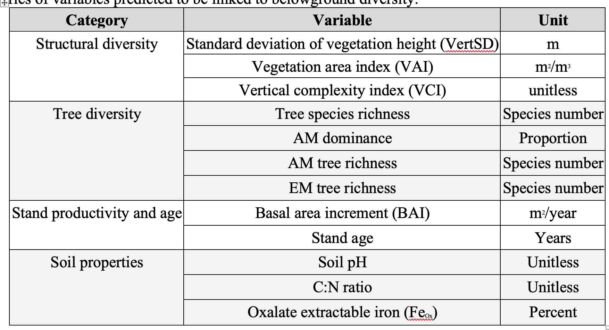

**Table 2.** Effects of plant community, productivity, canopy structure, and soil properties on the alpha diversity of soil microbial communities calculated with the inverse Simpson’s index. Linear coefficients (β) indicate the strength and direction of the effects of model parameters and are standardized within models to allow for comparison. Partial R2 and p values are reported only for trends significant at α= 0.05.

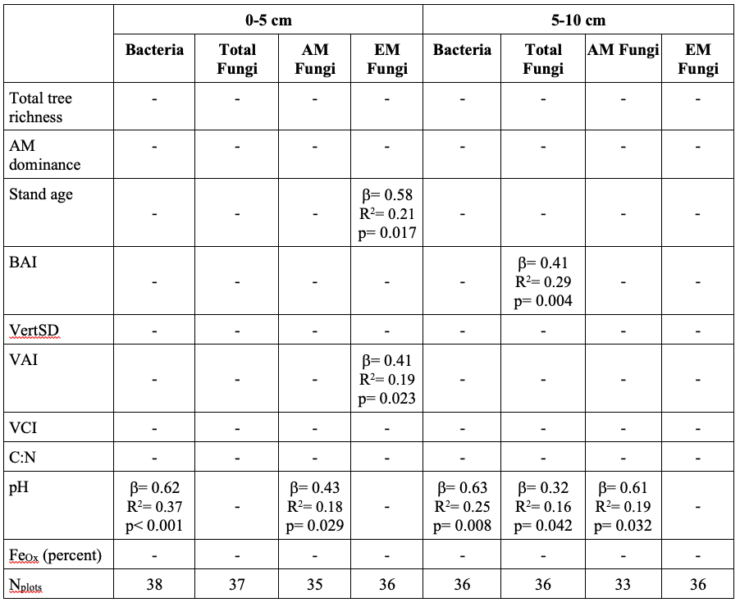

**Table 3.** Significant predictors of microbial community composition (beta diversity) explained by structural diversity and environmental variables in a distance-based redundancy analysis. X2 and p values are reported only for a predictor category that explains significant variation in the community composition at α= 0.05. 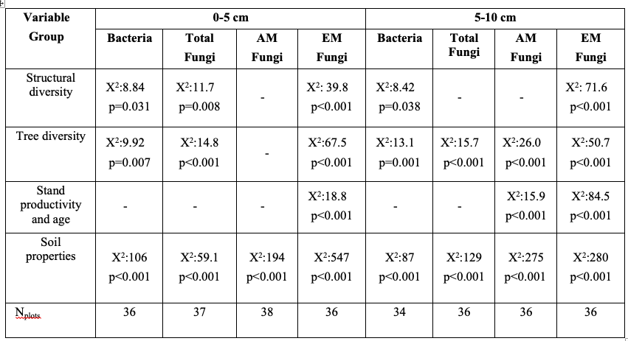

Figure Captions

**Figure 1**. Forest structural diversity may influence soil microbial diversity through several pathways. First, a less structurally diverse forest (a) may support lower soil microbial diversity than a structurally complex forest (b) due to less effective light capture (yellow arrows), leading to lower net primary productivity and less belowground carbon allocation to microbial communities (green shaded regions in inset figures indicate root carbon exudation). Lower aboveground structural complexity may also be associated with less complex rooting architecture, providing fewer niches for soil microorganisms. Indirectly, changes in structural complexity at the stand level may be associated with stand age and evenness of tree age classes, or with tree species richness, both of which likely influence soil microbial community composition and richness.

**Figure 2.** Location of study sites within the central hardwood region of Indiana, USA (NPlots = 38).

**Figure 3.** Relationship between vegetation area index (VAI) and forest stand age and alpha diversity of EM fungi, calculated with the inverse Simpson’s index. Points represent measured values of microbial richness at 0-5 cm and 5-10 cm soil depths and VAI and stand age of plots in forests across Indiana; solid line represents the marginal effects of each predictor independent of the effects of other structural diversity variables, and is plotted only for soil depths where the relationship was significant (α=0.05; Table 2).

**Figure 4.** Variance explained by each category of predictors that were indicated significant (p < 0.05) in the dbRDA model at 0-5 cm (a-d) and 5-10 cm (e-h) soil depths for bacterial community (ae), total fungal community (bf), AMF community (cg), and EMF community (dh). See Table 3 for model X2 and p-values for each significant predictor category.

**Figure 1**

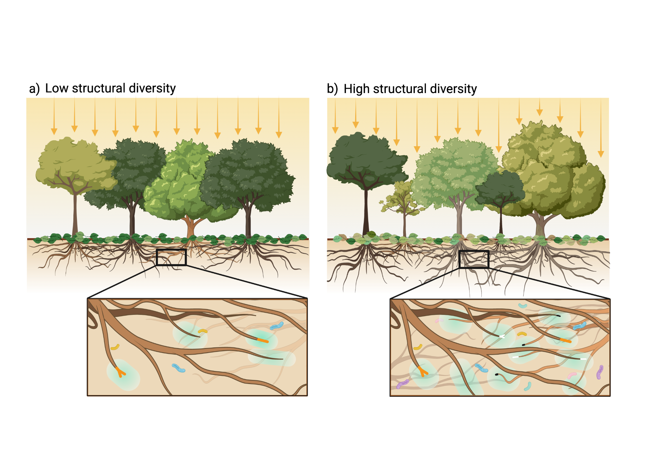

**Figure 2**

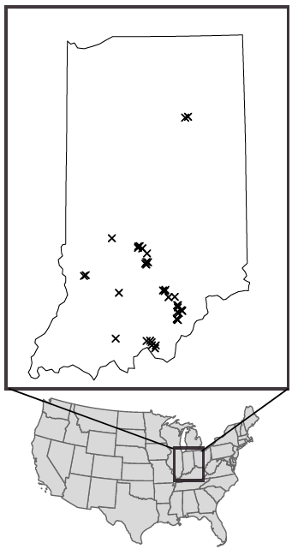

**Figure 3**

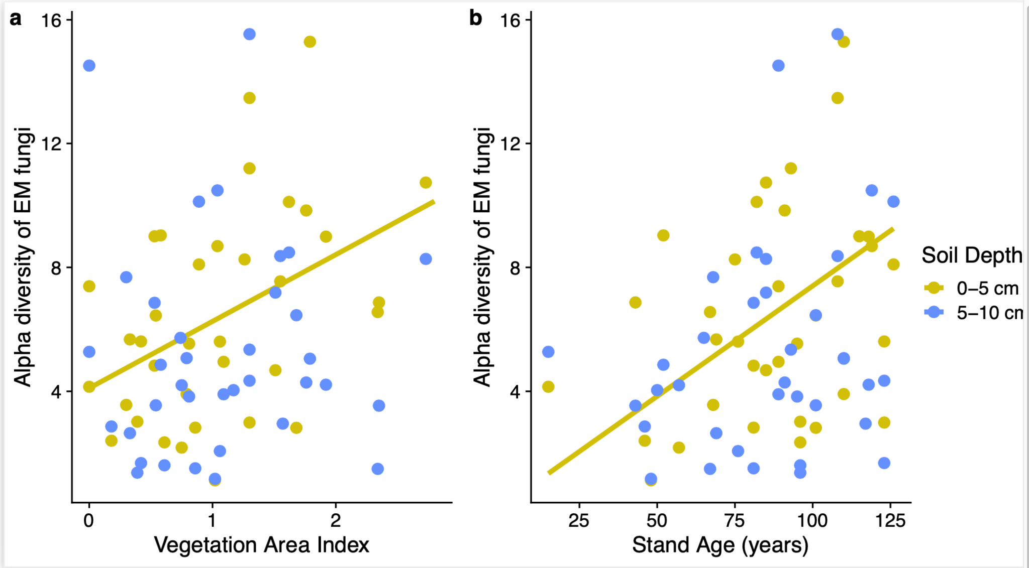

**Figure 4**

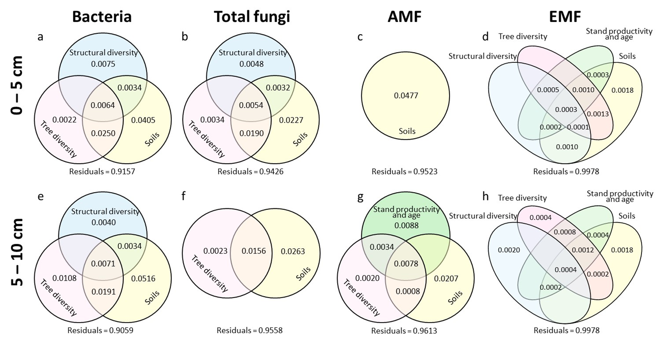

**Table 1.** Soil, plant, and stand-level variables predicted to be linked to microbial alpha and beta diversity in forest soils. The effect of each variable was assessed individually in models of microbial species richness and in categorial groups for models of microbial community composition. Structural diversity variables were calculated from LiDAR data, tree diversity and stand productivity and age data were gathered from the Indiana Continuous Forest Inventory (CFI) project, and soil properties were measured from samples collected in each CFI plot in the growing season of 2020.

|  |  |  |
| --- | --- | --- |
| **Category** | **Variable** | **Unit** |
| Structural diversity | Standard deviation of vegetation height (VertSD) | m |
| Vegetation area index (VAI) | m2/m3 |
| Vertical complexity index (VCI) | unitless |
| Tree diversity | Tree species richness | Species number |
| AM dominance | Proportion |
| AM tree richness | Species number |
| EM tree richness | Species number |
| Stand productivity and age | Basal area increment (BAI) | m2/year |
| Stand age | Years |
| Soil properties | Soil pH | Unitless |
| C:N ratio | Unitless |
| Oxalate extractable iron (FeOx) | Percent |

|  |  |  |  |  |  |  |  |  |
| --- | --- | --- | --- | --- | --- | --- | --- | --- |
|  | **0-5 cm** | | | | **5-10 cm** | | | |
| **Bacteria** | **Total Fungi** | **AM Fungi** | **EM Fungi** | **Bacteria** | **Total Fungi** | **AM Fungi** | **EM Fungi** |
| Total tree richness | - | - | - | - | - | - | - | - |
| AM dominance | - | - | - | - | - | - | - | - |
| Stand age | - | - | - | β= 0.58  R2= 0.21  p= 0.017 | - | - | - | - |
| BAI | - | - | - | - | - | β= 0.41  R2= 0.29  p= 0.004 | - | - |
| VertSD | - | - | - | - | - | - | - | - |
| VAI | - | - | - | β= 0.41  R2= 0.19  p= 0.023 | - | - | - | - |
| VCI | - | - | - | - | - | - | - | - |
| C:N | - | - | - | - | - | - | - | - |
| pH | β= 0.62  R2= 0.37  p< 0.001 | - | β= 0.43  R2= 0.18  p= 0.029 | - | β= 0.63  R2= 0.25  p= 0.008 | β= 0.32  R2= 0.16  p= 0.042 | β= 0.61  R2= 0.19  p= 0.032 | - |
| FeOx (percent) | - | - | - | - | - | - | - | - |
| Nplots | 38 | 37 | 35 | 36 | 36 | 36 | 33 | 36 |

**Table 2.** Effects of plant community, productivity, canopy structure, and soil properties on the alpha diversity of soil microbial communities calculated with the inverse Simpson’s index. Linear coefficients (β) indicate the strength and direction of the effects of model parameters and are standardized within models to allow for comparison. Partial R2 and p values are reported only for trends significant at α= 0.05.

**Table 3.** Significant predictors of microbial community composition (beta diversity) explained by structural diversity and environmental variables in a distance-based redundancy analysis. X2 and p values are reported only for a predictor category that explains significant variation in the community composition at α= 0.05. The specific predictors within each variable group are described in Table 1.

|  |  |  |  |  |  |  |  |  |
| --- | --- | --- | --- | --- | --- | --- | --- | --- |
| **Variable**  **Group** | **0-5 cm** | | | | **5-10 cm** | | | |
| **Bacteria** | **Total**  **Fungi** | **AM**  **Fungi** | **EM**  **Fungi** | **Bacteria** | **Total Fungi** | **AM**  **Fungi** | **EM**  **Fungi** |
| Structural diversity | Χ2:8.84  p=0.031 | Χ2:11.7  p=0.008 | - | Χ2: 39.8  p<0.001 | Χ2:8.42  p=0.038 | - | - | Χ2: 71.6  p<0.001 |
| Tree diversity | Χ2:9.92  p=0.007 | Χ2:14.8  p<0.001 | - | Χ2:67.5  p<0.001 | Χ2:13.1  p=0.001 | Χ2:15.7  p<0.001 | Χ2:26.0  p<0.001 | Χ2:50.7  p<0.001 |
| Stand productivity and age | - | - | - | Χ2:18.8  p<0.001 | - | - | Χ2:15.9  p<0.001 | Χ2:84.5  p<0.001 |
| Soil properties | Χ2:106  p<0.001 | Χ2:59.1  p<0.001 | Χ2:194  p<0.001 | Χ2:547  p<0.001 | Χ2:87  p<0.001 | Χ2:129  p<0.001 | Χ2:275  p<0.001 | Χ2:280  p<0.001 |
| Nplots | 36 | 37 | 38 | 36 | 34 | 36 | 36 | 36 |